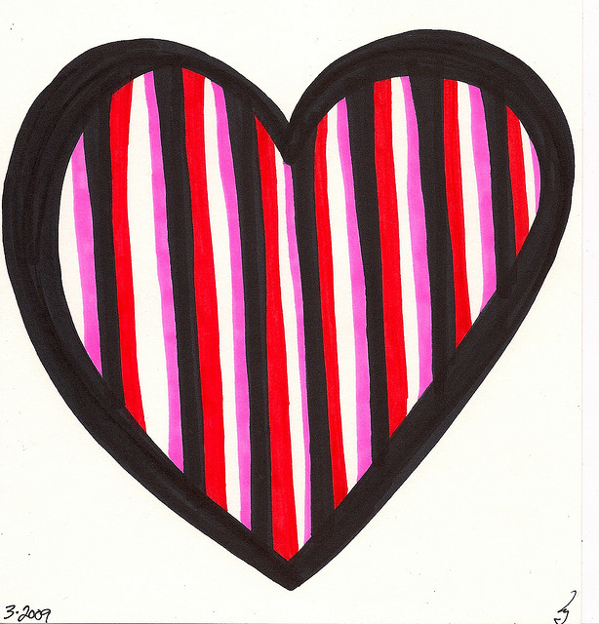
 |  | A.E. Mills Intermediate School
February 2018 |  | Hawk Pride - H – Honesty A – Always with Respect W – Will be Responsible K – Kind and Caring S – Safety First  For up to date information and news, please follow Mills on Twitter @millsinter or access our website from fldusd.org.
Sun | Mon |  | Tue | Wed | Thu | Fri | Sat
 |  |  |  |  | 1  Blackout Bullying! | 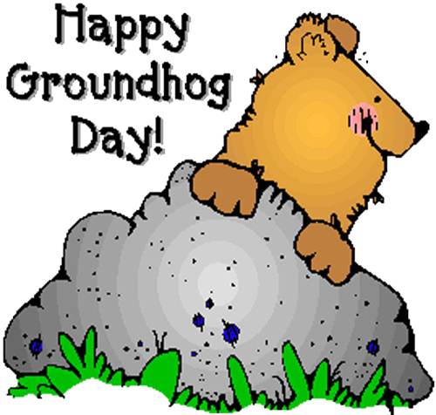  2 | 3  Saturday School  9-1
  4 | 5  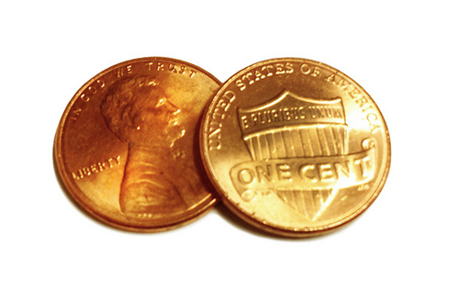  Pennies for Patients Begins  ELPAC This Week! |  | 6  Parent Club Meeting @ 5:30   | 7  1:45 Release   | 8  Blackout Bullying!  Student Council Meeting @ 9:30  Board of Trustees’ Meeting @ 7:00 | 9  Valentine Grams Due Today!   | 10  Saturday School  9-1
11 | 12  School Holiday  School Not in Session |  | 13  PIQE @ 5:30 PM | 14  1:45 Release  Happy Valentine’s Day! | 15  Blackout Bullying!  Spring Fundraiser Kick-Off | 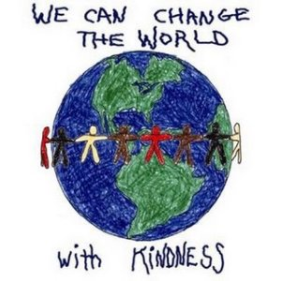  16 | 17  Saturday School  9-1  Random Acts of Kindness Day
18   | 19  Presidents' Day  School Not in Session |  | 20  Ned Show Assembly Today!  PIQE @ 5:30 PM | 21  1:45 Release | 22  Blackout Bullying!  Spelling Bee @ Mills | 23  Pennies for Patients Ends  End of 2nd Trimester | 24  Saturday School  9-1
25  Career Week! Dress up as your Future Self in your Career of Choice on Friday, March 2! | 26 |  | 27  PIQE @ 5:30 PM | 28  SOM/Hawk Pride Luncheon

