 |  | A.E. Mills Intermediate School
December 2017 |  | Hawk Pride - H – Honesty A – Always with Respect W – Will be Responsible K – Kind and Caring S – Safety First  For up to date information and news, please follow Mills on Twitter @millsinter or access our website from fldusd.org.
Sun | Mon |  | Tue | Wed | Thu | Fri | Sat
 |  |  |  |  | Blackout Bullying!  Every Thursday, students are encouraged to wear black to Stand Up Against Bullying! | 1  PBIS Expectation Rotation  Hawk-a-Thon  $ Due | 2  Saturday School  9-1
3 | 4 |  | 5 | 6  1:45 Release | 7  Blackout Bullying!  Fundraiser Inflatable Day!  ASP Winter Program | 8  Healthy Smiles is Here!   | 9  Saturday School  9-1
10  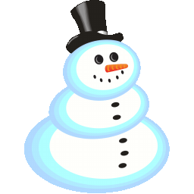 | 11  SSC/ELAC Meeting @ 4:00 ~ Library  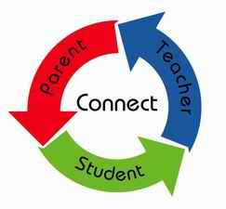  Parent Club Meeting @ 5:30 |  | 12  Hanukkah  Begins at Sunset | 13  1:45 Release  3rd Grade Winter Performance @ 9:00  Winter Wishes Grams Due! | 14  Blackout Bullying!  5th Grade Winter Performance @ 8:30  4th Grade Winter Performance @ 9:45  SOM Photos | 15  ASB Dress Up Day!  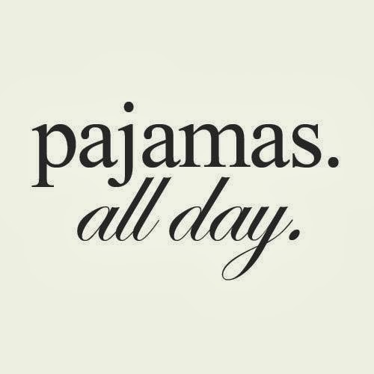  Wear Pajamas! | 16
17  Winter Vacation – December 18th – January 8th ~ School Resumes on January 9th, 2018 | 18 |  | 19 | 20 | 21 | 22 | 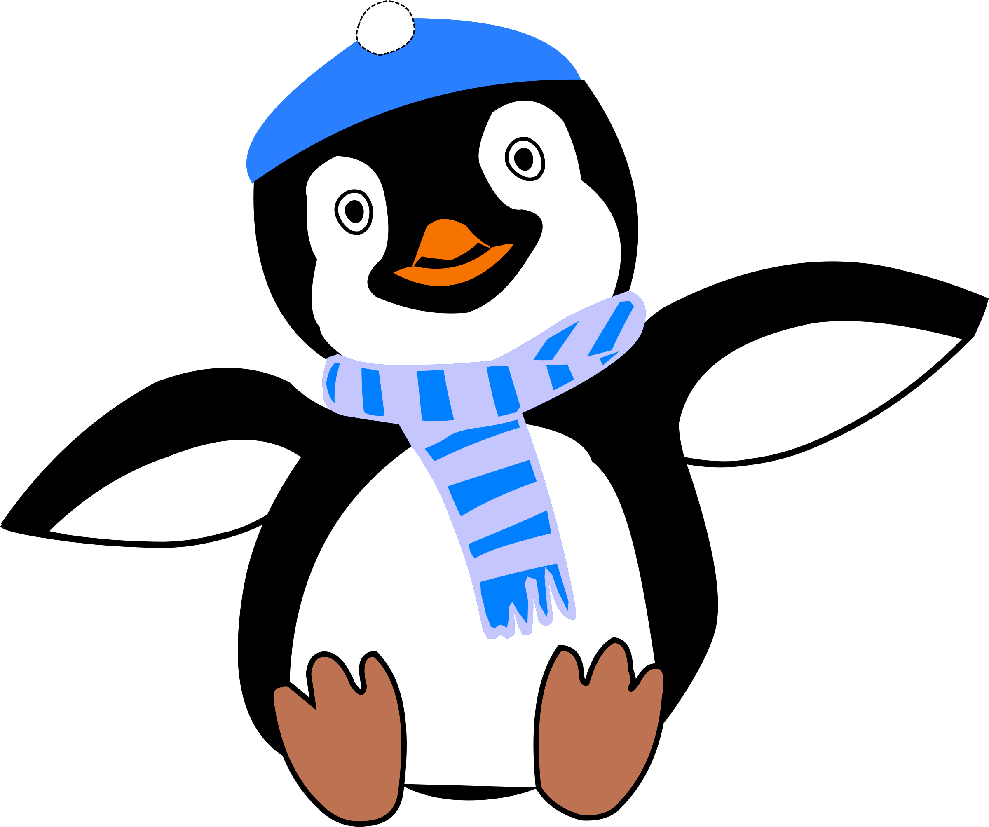  23
24/31  New Year’s Eve | 25  Christmas Day |  | 26  Kwanzaa Begins | 27 | 28 | 29 | 30

